SAMR model – how to apply in Classrooms
Lesson: Equations of circles: (x - a)² + (y - b )² = R²
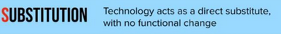
Use geogebra to draw circles instead of drawing circles on the white board,

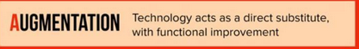
Students will be using geogebra, to draw circles, and check how the equation, radius, diameter… or circles change when they modify with the measures of it.

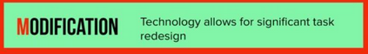
Students will be able to view graphically circles according to their equations; they may be able to create videos.

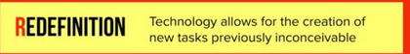
Create an account, a blog, a page or a folder where they can save their and upload the output of their work. They may share their work and compare it to others.

Bya3emlo new shaper, there has to be something, not only a matter pf communication ,

